ORDINANCE NO. 2016-__
AN ORDINANCE
VACATING A PORTION OF A STREET AND AN ALLEY
LOCATED IN THE CITY OF AUBURN, INDIANA

SUMMARY
This ordinance authorizes the vacations of undeveloped portions of the public rights-of-way located in the Natural Gas Addition to the City of Auburn. The first right-of-way lies south of lots eighty-five (85) and one-hundred (100) extending south to lots ninety-two (92)and ninety-three (93) and located west of lots ninety-nine (99) thru ninety-three (93) and east of lots eighty-six (86) through ninety-two (92). That section of right-of-way being approximately twenty (20) feet wide and approximately three-hundred fifty (350) feet long; vacating the undeveloped portion of an alleyway. The second right-of-way lies south of lot eighty-five (85) extending south to lot ninety-two (92) and located west of lots eighty-six (86) through ninety-two (92). That section of right-of-way being approximately thirty (30) feet wide and approximately three-hundred fifty (350) feet long; vacating the undeveloped portion of a street. The third right-of-way lies north of lots ninety-two (92) and ninety-three (93) and runs east and west. That section of right-of-way being approximately twelve (12) feet wide and approximately three-hundred (300) feet long; vacating the undeveloped portion of an alleyway. The areas that are located in the proposed vacated rights-of-way are more particularly shown on the Exhibit attached hereto as Exhibit “A”.

_________x_______ Recorder’s Office ___X_____ Publish Public Hearing
_________________ Auditor’s Office ____________________________
_________________ Clerk’s Office ___X___ Publish O/R after adoption
_________________ Other ____________________________

____x_____ Building Department
____x____ Engineering Department
________ DeKalb County Plan Commission
____x____ Internet Code Site –Council Ordinances

ORDINANCE NO. 2016-___
AN ORDINANCE
VACATING A PORTION OF A STREET AND AN ALLEY
LOCATED IN THE CITY OF AUBURN, INDIANA

WHEREAS, a petition was filed with the City of Auburn, Indiana to vacate undeveloped portions of the public rights-of-way located in the Natural Gas Addition to the City of Auburn. The area being vacated is as follows:

The first right-of-way lies south of lots eighty-five (85) and one-hundred (100) extending south to lots ninety-two (92) and ninety-three (93) and located west of lots ninety-nine (99) thru ninety-three (93) and east of lots eighty-six (86) through ninety-two (92). That section of right-of-way being approximately twenty (20) feet wide and approximately three-hundred fifty (350) feet long; vacating the undeveloped portion of an alleyway. The second right-of-way lies south of lot eighty-five (85) extending south to lot ninety-two (92) and located west of lots eighty-six (86) through ninety-two (92). That section of right-of-way being approximately thirty (30) feet wide and approximately three-hundred fifty (350) feet long; vacating the undeveloped portion of a street. The third right-of-way lies north of lots ninety-two (92) and ninety-three (93) and runs east and west. That section of right-of-way being approximately twelve (12) feet wide and approximately three-hundred feet (300) long; vacating the undeveloped portion of an alleyway; and,
WHEREAS, a public hearing of the City of Auburn Common Council was held on the 19th day of July, 2015 at 6:00 P.M. at the Auburn Common Council Chambers regarding the petition for vacation, and

WHEREAS, public notice has been provided to the affected landowners, and

WHEREAS, a second reading of the Ordinance was held on July 19, 2016, and
WHEREAS, after due consideration and opportunity for public notice and comment; and

IT IS NOW THEREFORE ORDAINED BY THE COMMON COUNCIL

OF THE CITY OF AUBURN, INDIANA THAT:

Section 1.
For those undeveloped portions of right-of-way see Exhibit “A”, consisting of one (1) page, which is attached hereto and made a part hereof further setting forth the area being vacated. One-half of the width of the first vacated right-of-way shall be awarded to each adjoining landowner. The full width of the second vacated right-of-way shall be awarded to the lots adjoining on the east. The full width of the third vacated right-of-way shall be awarded to lots ninety-two (92) and ninety-three (93).
Section 2.
The Municipal City of Auburn shall retain an easement across the vacated rights-of-way for the purpose of providing, maintaining, and expanding utilities in the future. The Municipal City of Auburn shall have the right to maintain, expand, and repair utilities within said rights-of-way.
BE IT FURTHER ORDAINED that this Ordinance shall be in full force and effect
from and after publication of the summary of this Ordinance in a newspaper of general
circulation in DeKalb County, Indiana. A full and complete copy of the Ordinance shall
be kept on the City of Auburn web-site under the Council information at
www.ci.auburn.in.us.
PASSED AND ADOPTED by the Common Council of the City of Auburn,
Indiana, this 19th day of July, 2016.
________________________________
James Finchum, Councilmember

ATTEST:

_________________________
Patricia Miller, Clerk-Treasurer

Presented by me to the Mayor of the City of Auburn, Indiana, this 19th day of
July, 2016.

______________________________
PATRICIA MILLER, Clerk-Treasurer

APPROVED AND SIGNED by me this 19th day of July, 2016.

_____________________________
NORMAN E. YODER, Mayor

VOTING: AYE NAY

Kevin Webb
James Finchum
Dennis (Matthew) K. Kruse II
Todd Sanderson
Michael Watson
Dennis Ketzenberger
Michael Walter

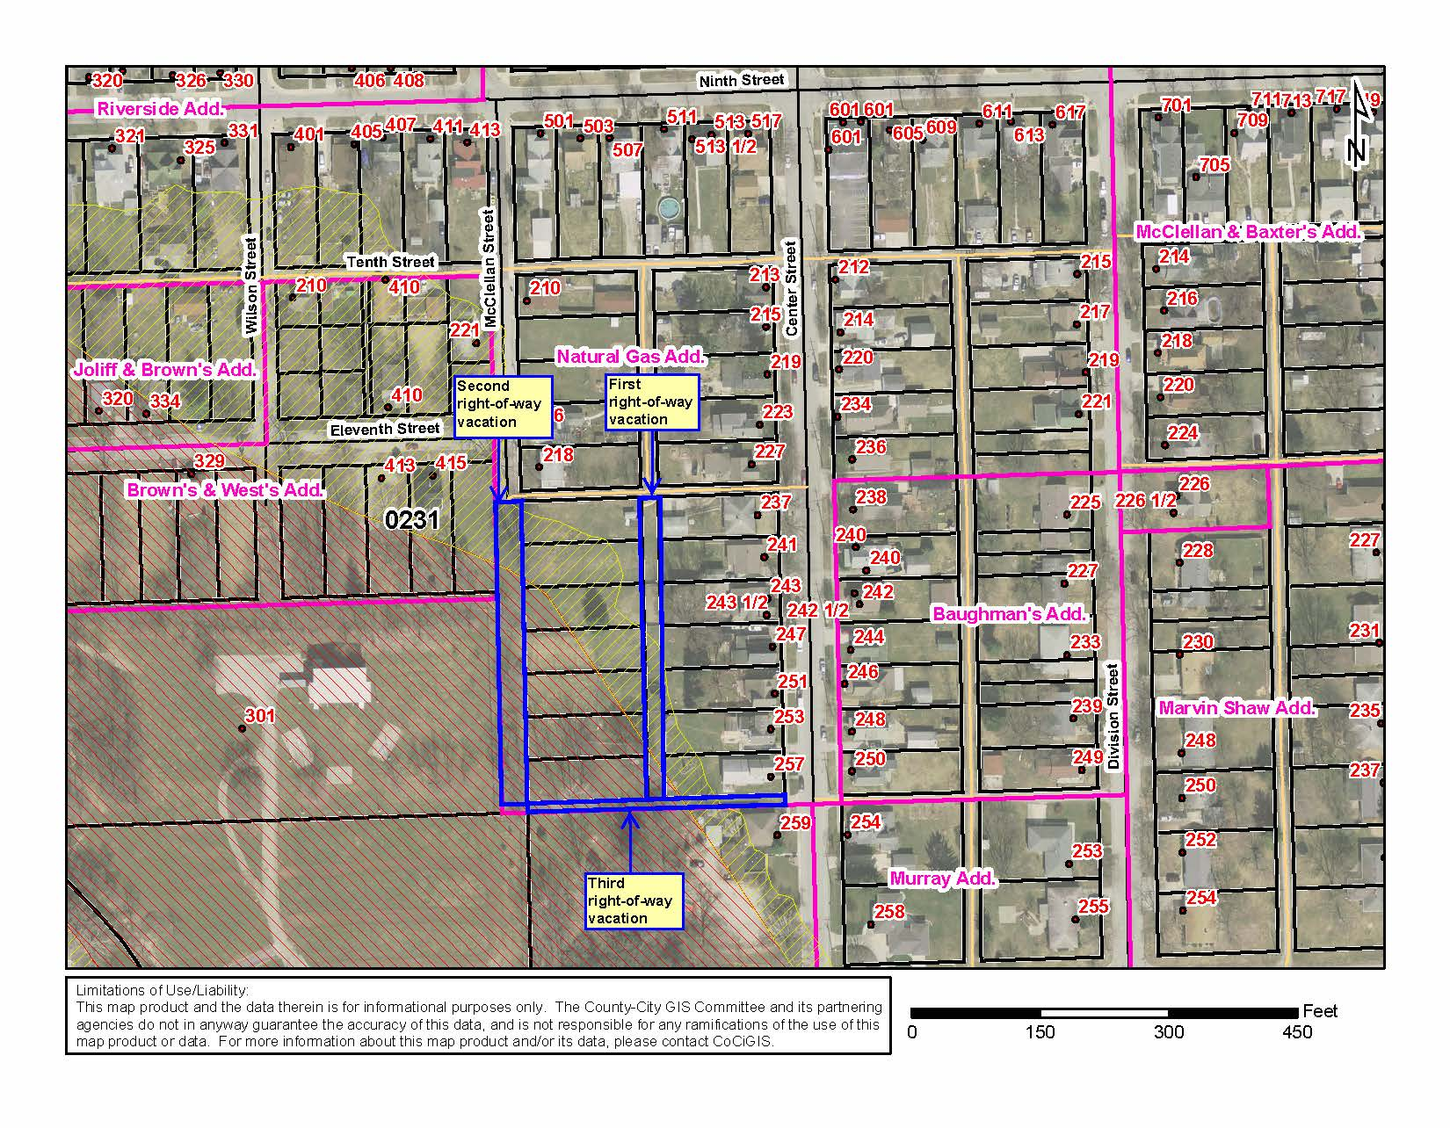
EXHIBIT “A”

